VISIT

TO THE NATIONAL GALLERY TO SEE
THE VAN GOGH “POETS AND LOVERS” EXHIBITION

THURSDAY 12TH DECEMBER 2024
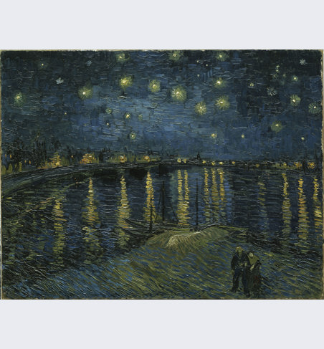
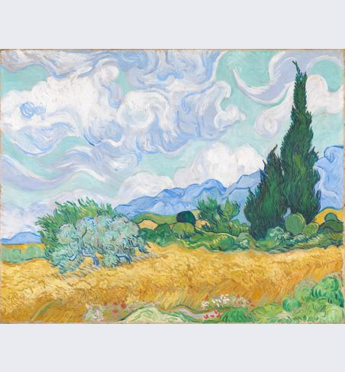

As part of its celebration of its 200th anniversary, the National Gallery has put together this “once in a lifetime” exhibition of the works of Van Gogh drawn from, not only its own Van Gogh paintings, but works from museums and private collections from all over the world. To quote from its website:
“Walk with a pair of lovers beneath a starry night. Look up at swirling clouds and cypress trees swaying in the wind. Stay a little while in Van Gogh’s favourite park, the ‘Poet’s Garden’, or under a shady tree in Saint-Rémy.
We’re bringing together your most loved of Van Gogh’s paintings from across the globe, some of which are rarely seen in public. They will be paired together with his extraordinary drawings.”
A coach will take us from Priory Lane, Burford to the National Gallery for our entry time mid-morning to the exhibition were we can spend as long or as little as we like. There will be plenty of time to wonder around the rest of the gallery, visit the National Portrait Gallery, or sit in Trafalgar Sq, or in a café, or do Christmas shopping before joining the coach mid-afternoon for our return journey to Burford.
Please sign up by filling in the booking form, or going to our website to book. Or contact Carolyn Walton at visits@theartssocietycotswolds.org.uk or phone me – numbers below.
A Mailchimp email will also be sent soon for you to book on line. I have to have at least 20 attendees as I have bought the tickets to the exhibition.
Carolyn Walton.
01993 822 296, or 07867 511 873.

